Assembly instructions for the linear gripper with a rotational wrist

By: Félix Méthot

Contents

Material 2

Wrist assembly 3

Gripper assembly 6

Connection the wrist to the gripper 10

Adding Camera 11

# Before starting

Before opening the CAD assembly in SolidWorks, you must change some settings so that SolidWorks does not open the default rack and pinion parts. To do so, uncheck the box "Make this folder the default search location for Toolbox components" in the *Hole Wizard/Toolbox* section of the settings. For more help, see [reference](https://forum.solidworks.com/thread/78786).

# Material

This is the material you will need to build this gripper

* A 3d printer (to print the components)
* 4x 6-32 Thread, 5/8" Long screws ([link](https://www.mcmaster.com/91770a150))
* 4x 6-32 Thread nuts ([link](https://www.mcmaster.com/91813a130))
* 4x 2-56 Thread, 5/8" Long screws ([link](https://www.mcmaster.com/91772a081))
* 4x 2-56 Thread nuts ([link](https://www.mcmaster.com/91813a110))
* HS-788HB Servo ([link](https://www.servocity.com/hs-788hb-servo))
* HS-40 Servo ([link](https://www.servocity.com/hitec-hs-40-servo))
* HS-5055MG Servo ([link](https://www.servocity.com/hs-5055mg-servo))
* Coupler (1/4") ([link](https://www.robotshop.com/ca/en/actobotics-set-screw-futaba-servo-shaft-coupler-1-4.html))
* 90° Pattern Mount ([link](https://www.servocity.com/90-hub-mount-bracket-a))
* ¼” – 1.5in long D-shaft ([link](https://www.robotshop.com/ca/en/actobotics-15x1-4-precision-d-shaft.html))
* FPV Camera ([link](https://www.banggood.com/Eachine-TX02-Super-Mini-AIO-5_8G-40CH-200mW-VTX-600TVL-14-Cmos-FPV-Camera-p-1088368.html?rmmds=myorder&cur_warehouse=CN))
* The accessories that come with the servos

Note: the camera support is not shown for it was added after the creation of this guide. To insert camera, see section Adding Camera.

# Wrist assembly

Step 1 – Take to 90° pattern mount  
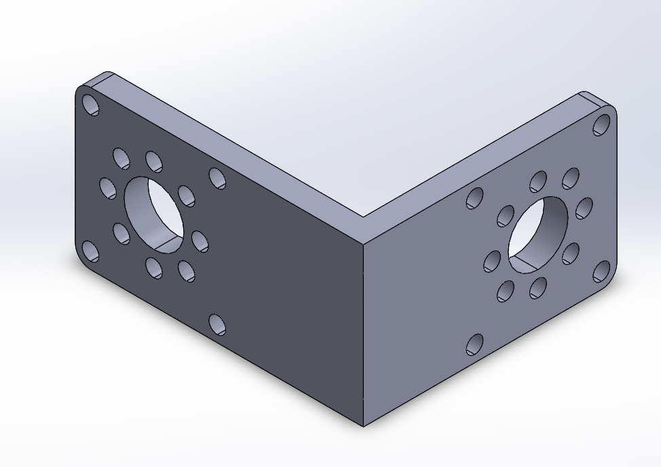

Step 2 – Secure motor support to the 90° pattern mount with the 6-32 nuts and screws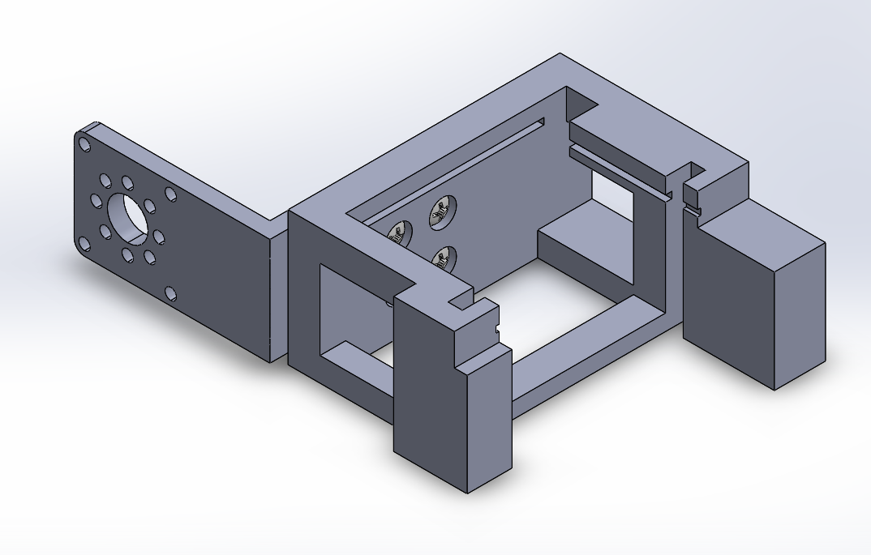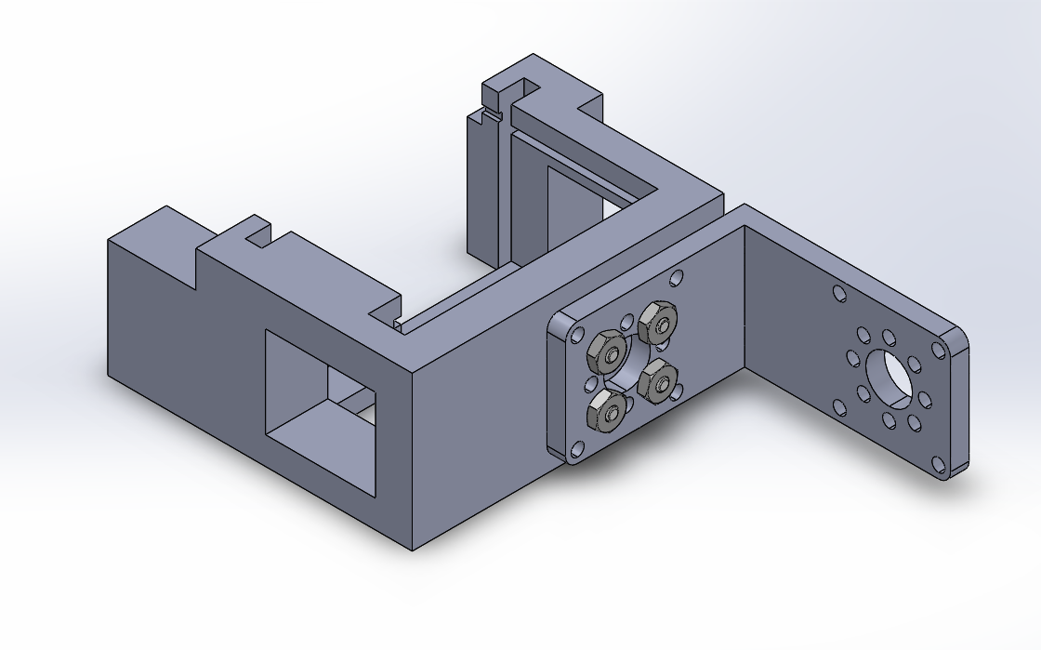

Step 3 – Insert HS-788HB Servo in the motor support   
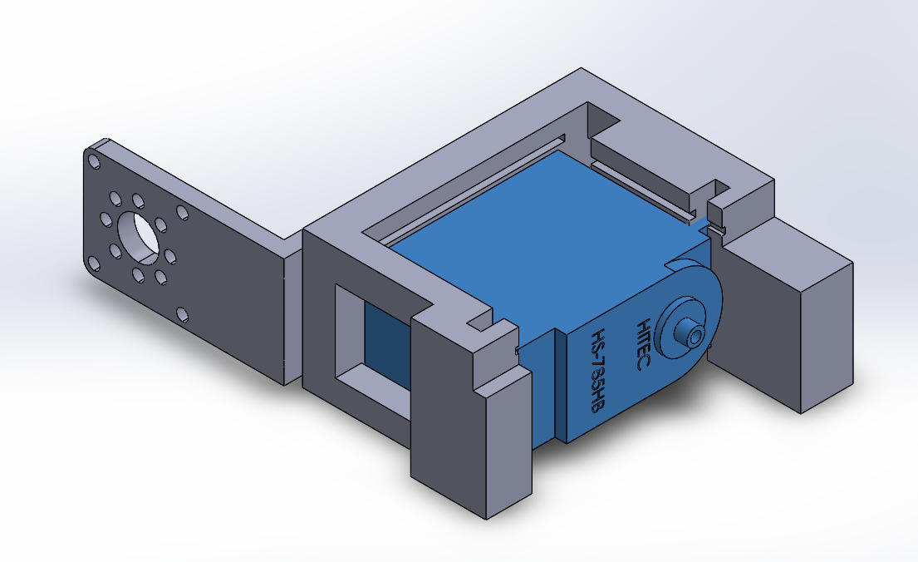 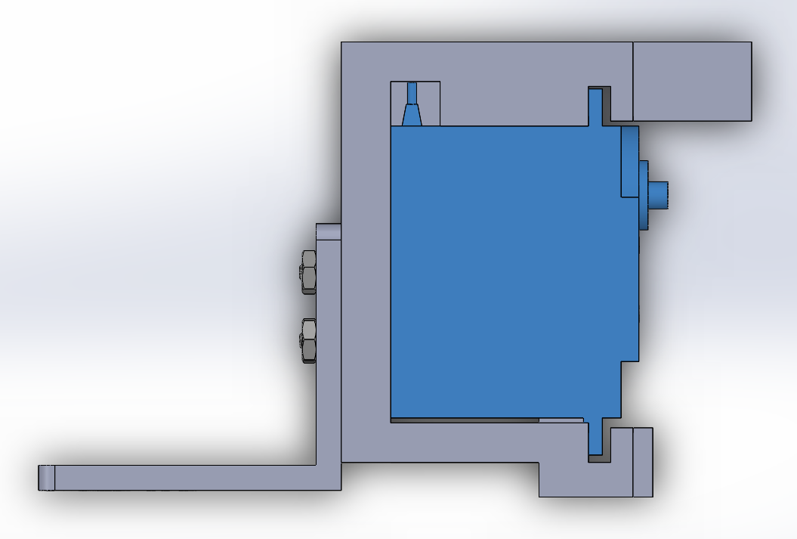

Step 4 – Insert support wall   
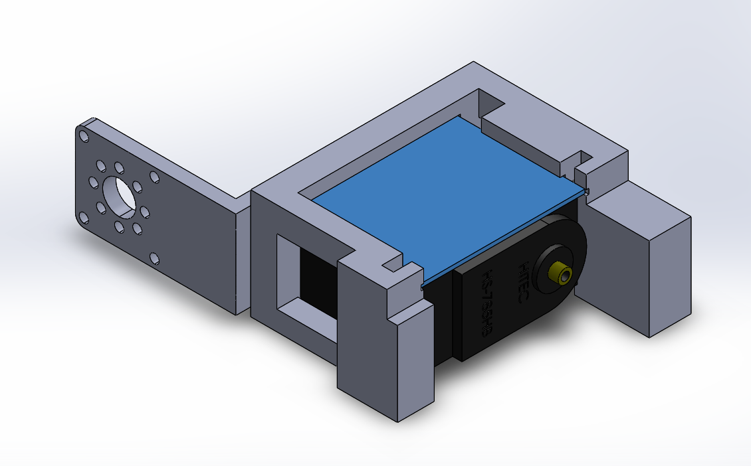

Step 5 – Screw coupler on to servo  
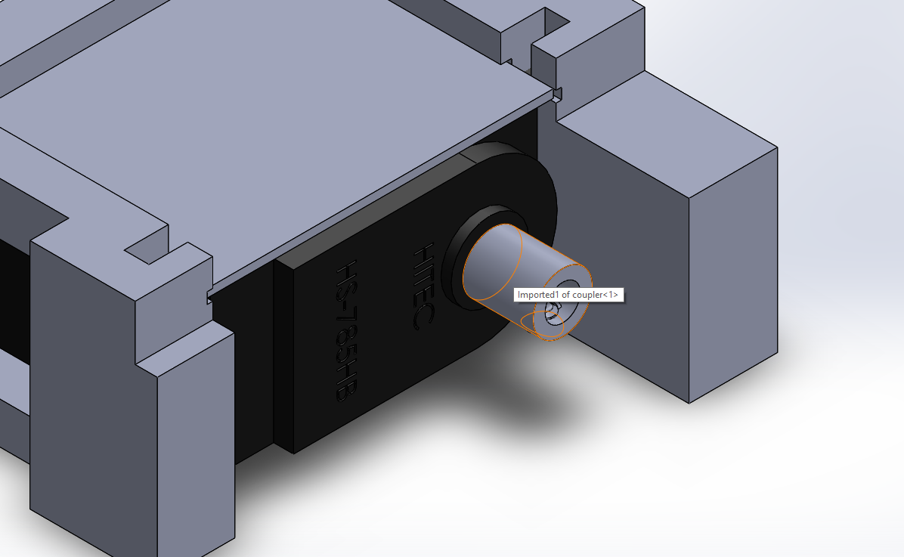

Step 6 – Insert D-shaft into coupler and secure firmly with the coupler screw 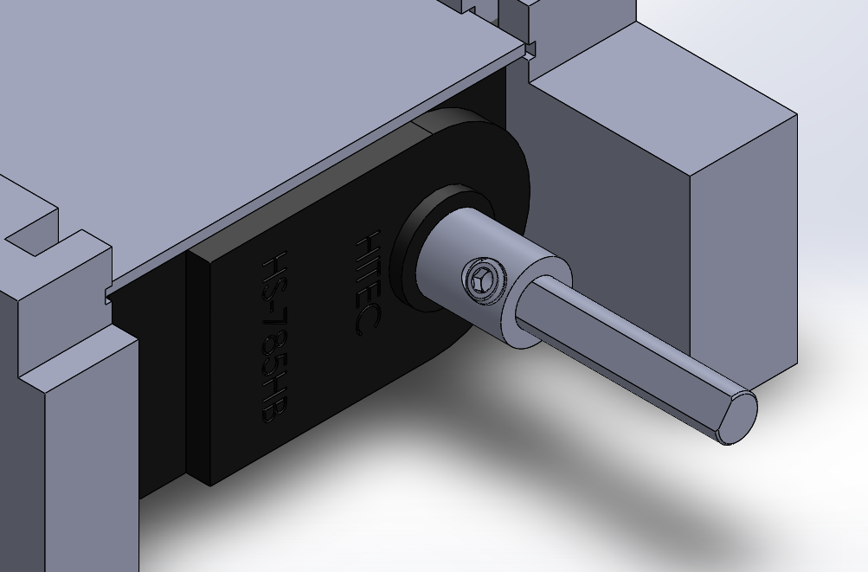

Step 7 – Glue on support roof, make sure the hole is aligned with the shaft (so the shaft can rotate freely)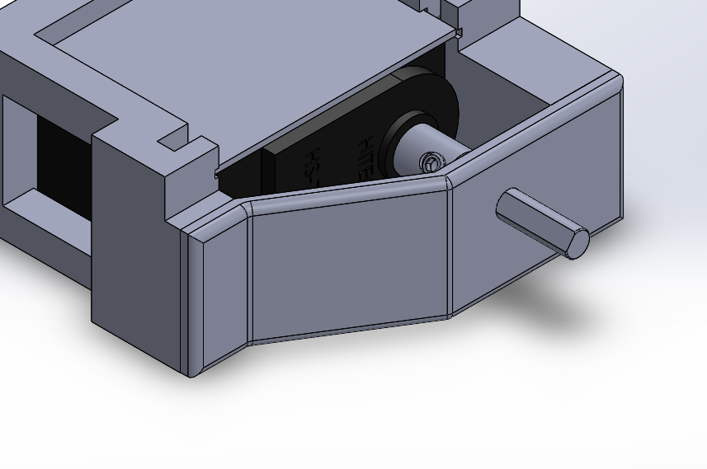

# Gripper assembly

Step 1 – Take gripper base  
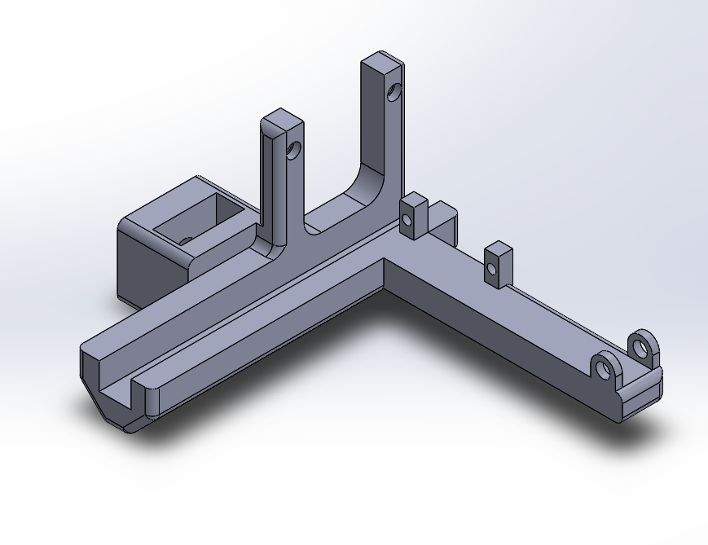

Step 2 – Secure HS-5055MG Servo to base with two 2-56 screws and two 2-56 bolts  
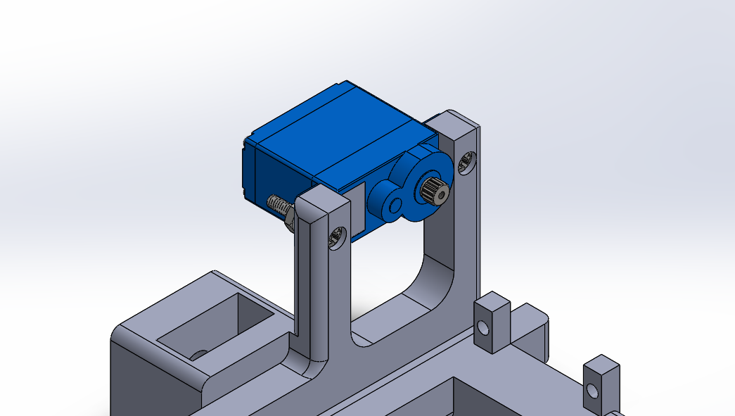 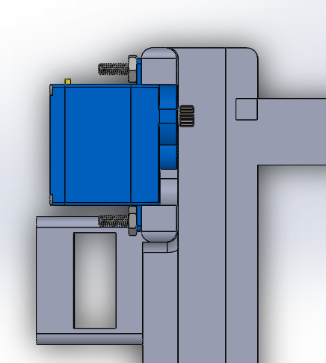

Step 3 – Secure HS-40 Servo to base with two 2-56 screws and two 2-56 bolts  
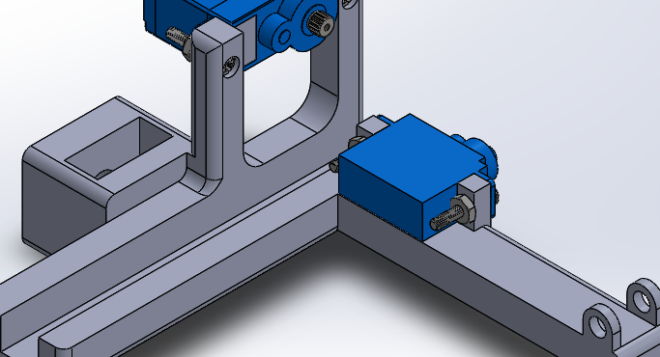 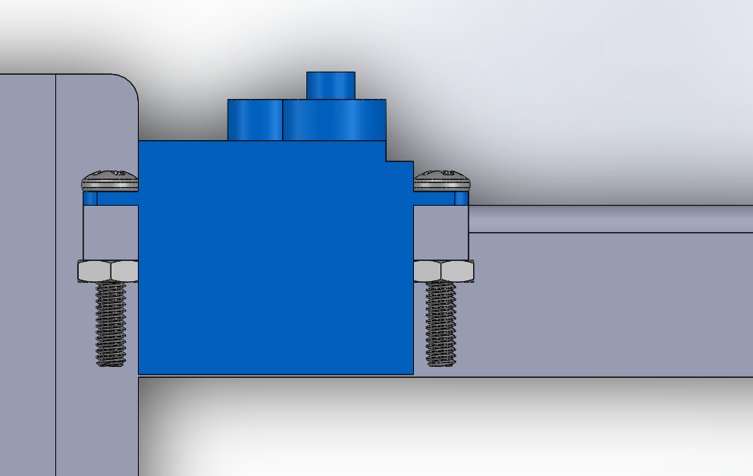

Step 4 – Glue the servo cross accessory (shown below) to the gear  
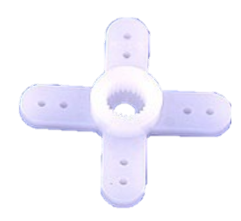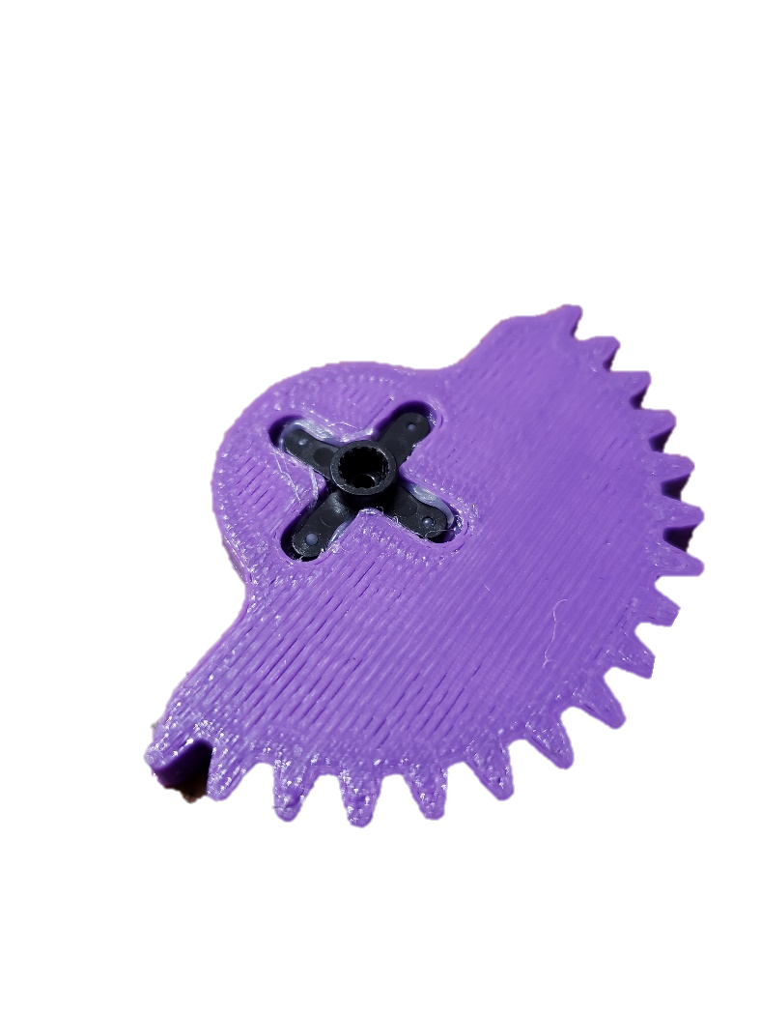

Step 5 – insert mobile gripper

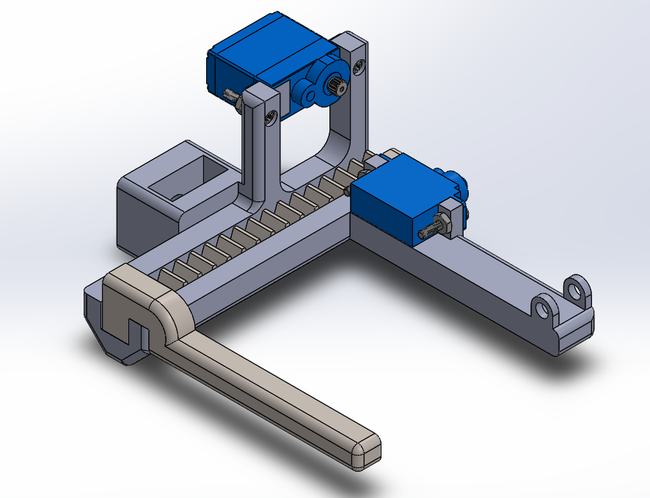

Step 6 – Close gripper  
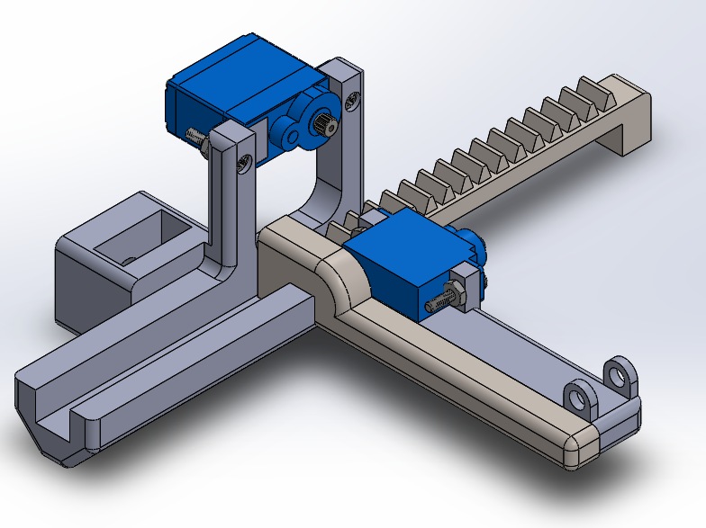

Step 7- insert gear in this position with the servomotor shaft turned completely counterclockwise

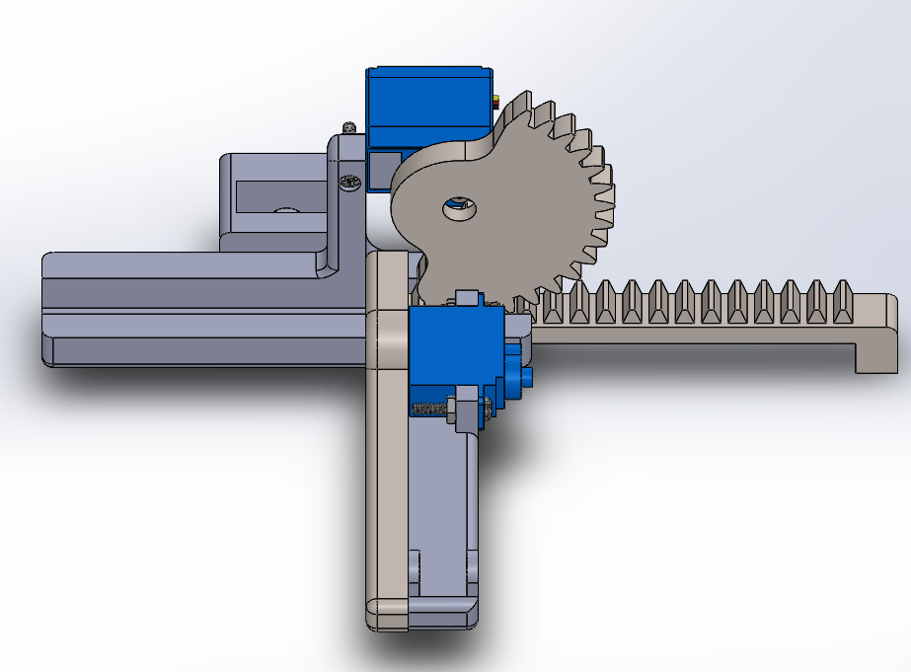 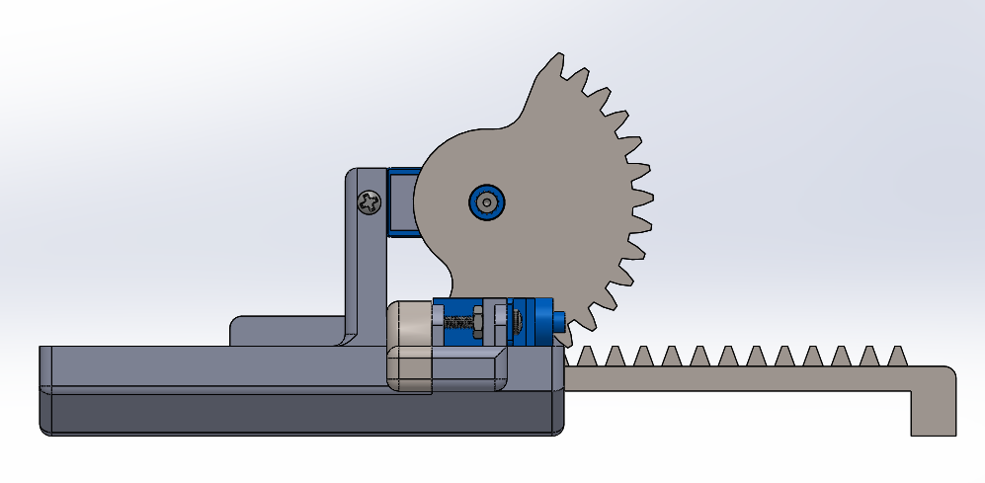

Step 8 – Pry in the ice cube flipper with a flat head screwdriver  
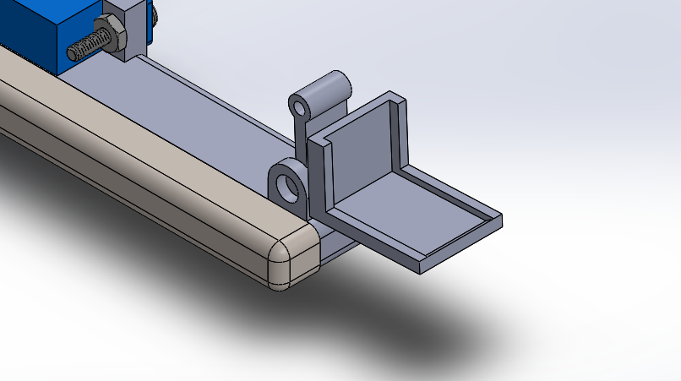

Step 9 – Add the servo accessory  
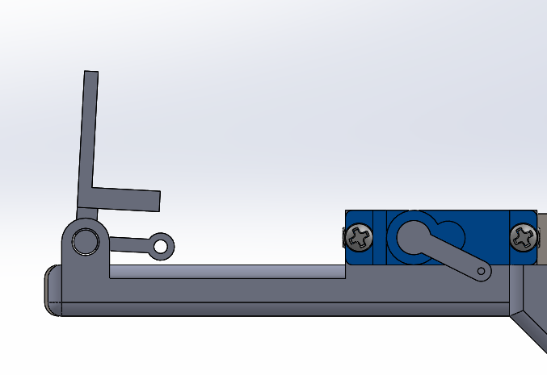

Step 10 – Choose one of the following options

(Option 1) Connect the flipper to the servo arm with rigid wire, you may have to slighlty modify the wire length but the ideal wire length is approximately 47mm.

(Option 2) Secure the link piece with wire running throught the holes, see below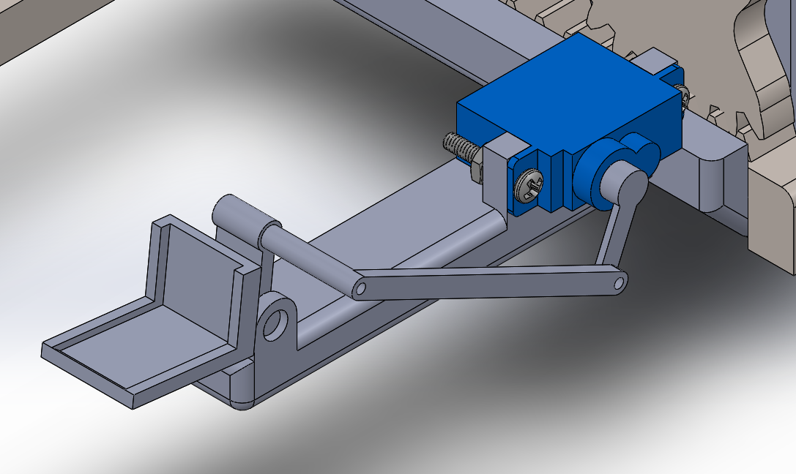

# Connection the wrist to the gripper

Below is shown how to connect the wrist and the gripper without showing all the components, this is done to demonstrate the assembly with less clutter. It is recommended to assemble both parts separately before assembling them together.

Step 1 – In the gripper base, insert the shaft collar with the screw in a vertical position 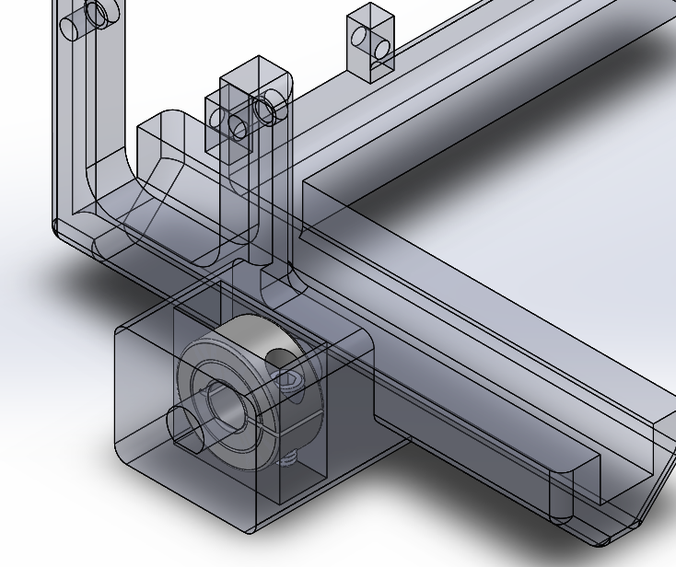

Step 2 – Insert the shaft until the base is flush with the motor support roof 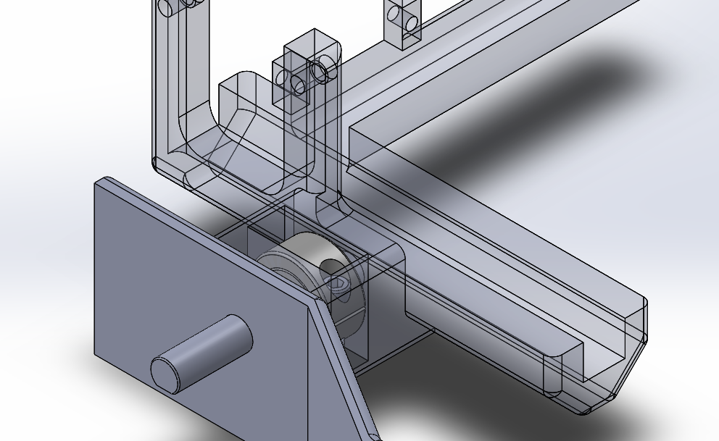 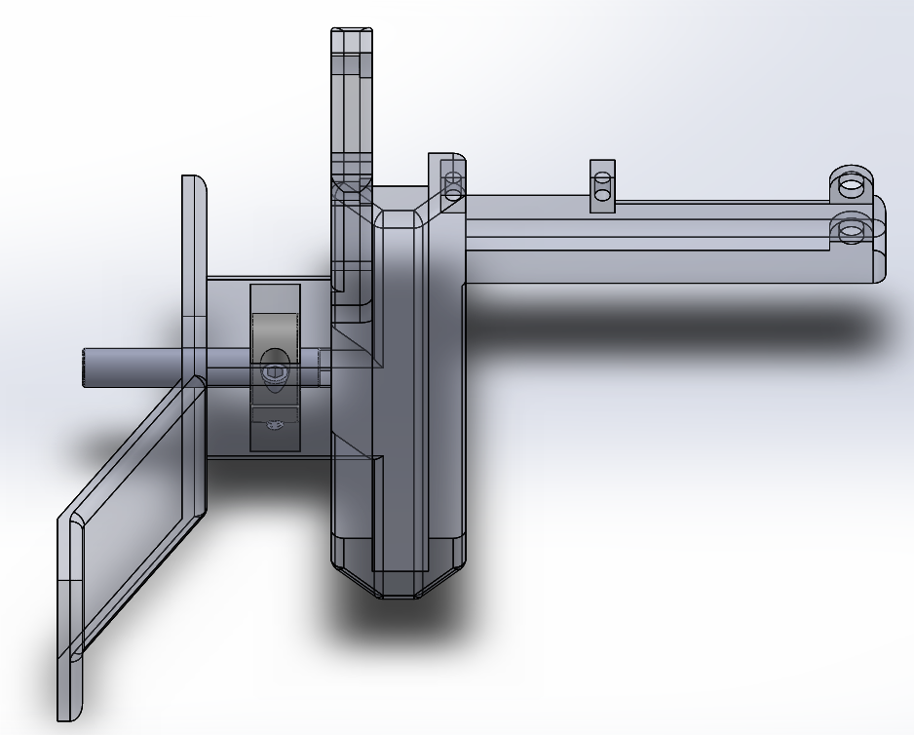

Step 3 – Once in place, tighten the shaft collar

# Adding Camera

Step 1 – Take the FPV camera and make sure it fits in the camera support  
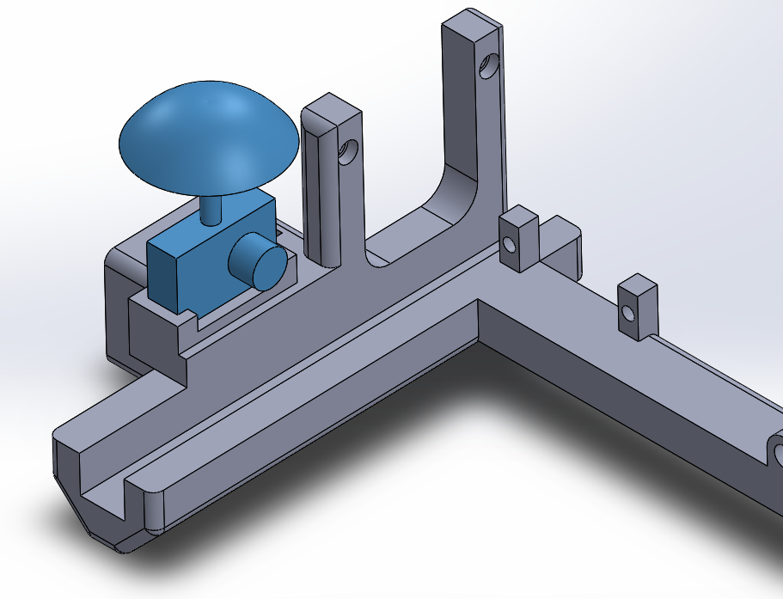

Step 2 – If it fits, apply a small layer of hot glue to the camera socket located on the gripper base and press camera into it